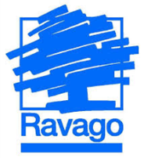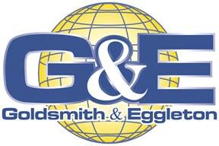

Goldsmith & Eggleton a Ravago Co.
Management Systems Policy

Goldsmith & Eggleton will be the Best Manufacturer of Masterbatches and Reprocessed Polymers our Stakeholders can Imagine by:

Continuously improving the effectiveness of ALL of our management systems to provide the highest quality products and services to reduce environmental impact and to improve the safety of our work environment to promote CUSTOMER, COMMUNITY, and EMPLOYEE satisfaction;

Encouraging our SUPPLIERS to support us through introduction of technology, quality, safety and environmental improvements focused on increasing efficiency, pollution prevention and waste reduction activities suitable to the nature of our business;

Demanding a 7S environment which requires compliance with RMA quality, safety and environmental procedures and work instructions, as well as providing training and development opportunities for all EMPLOYEES;

Supporting our COMMUNITY by complying with applicable international standards, as well as other compliance obligations to ensure the continuity of our business; and

Demonstrating to our SHAREHOLDERS our success through achievement of our management systems goals.

